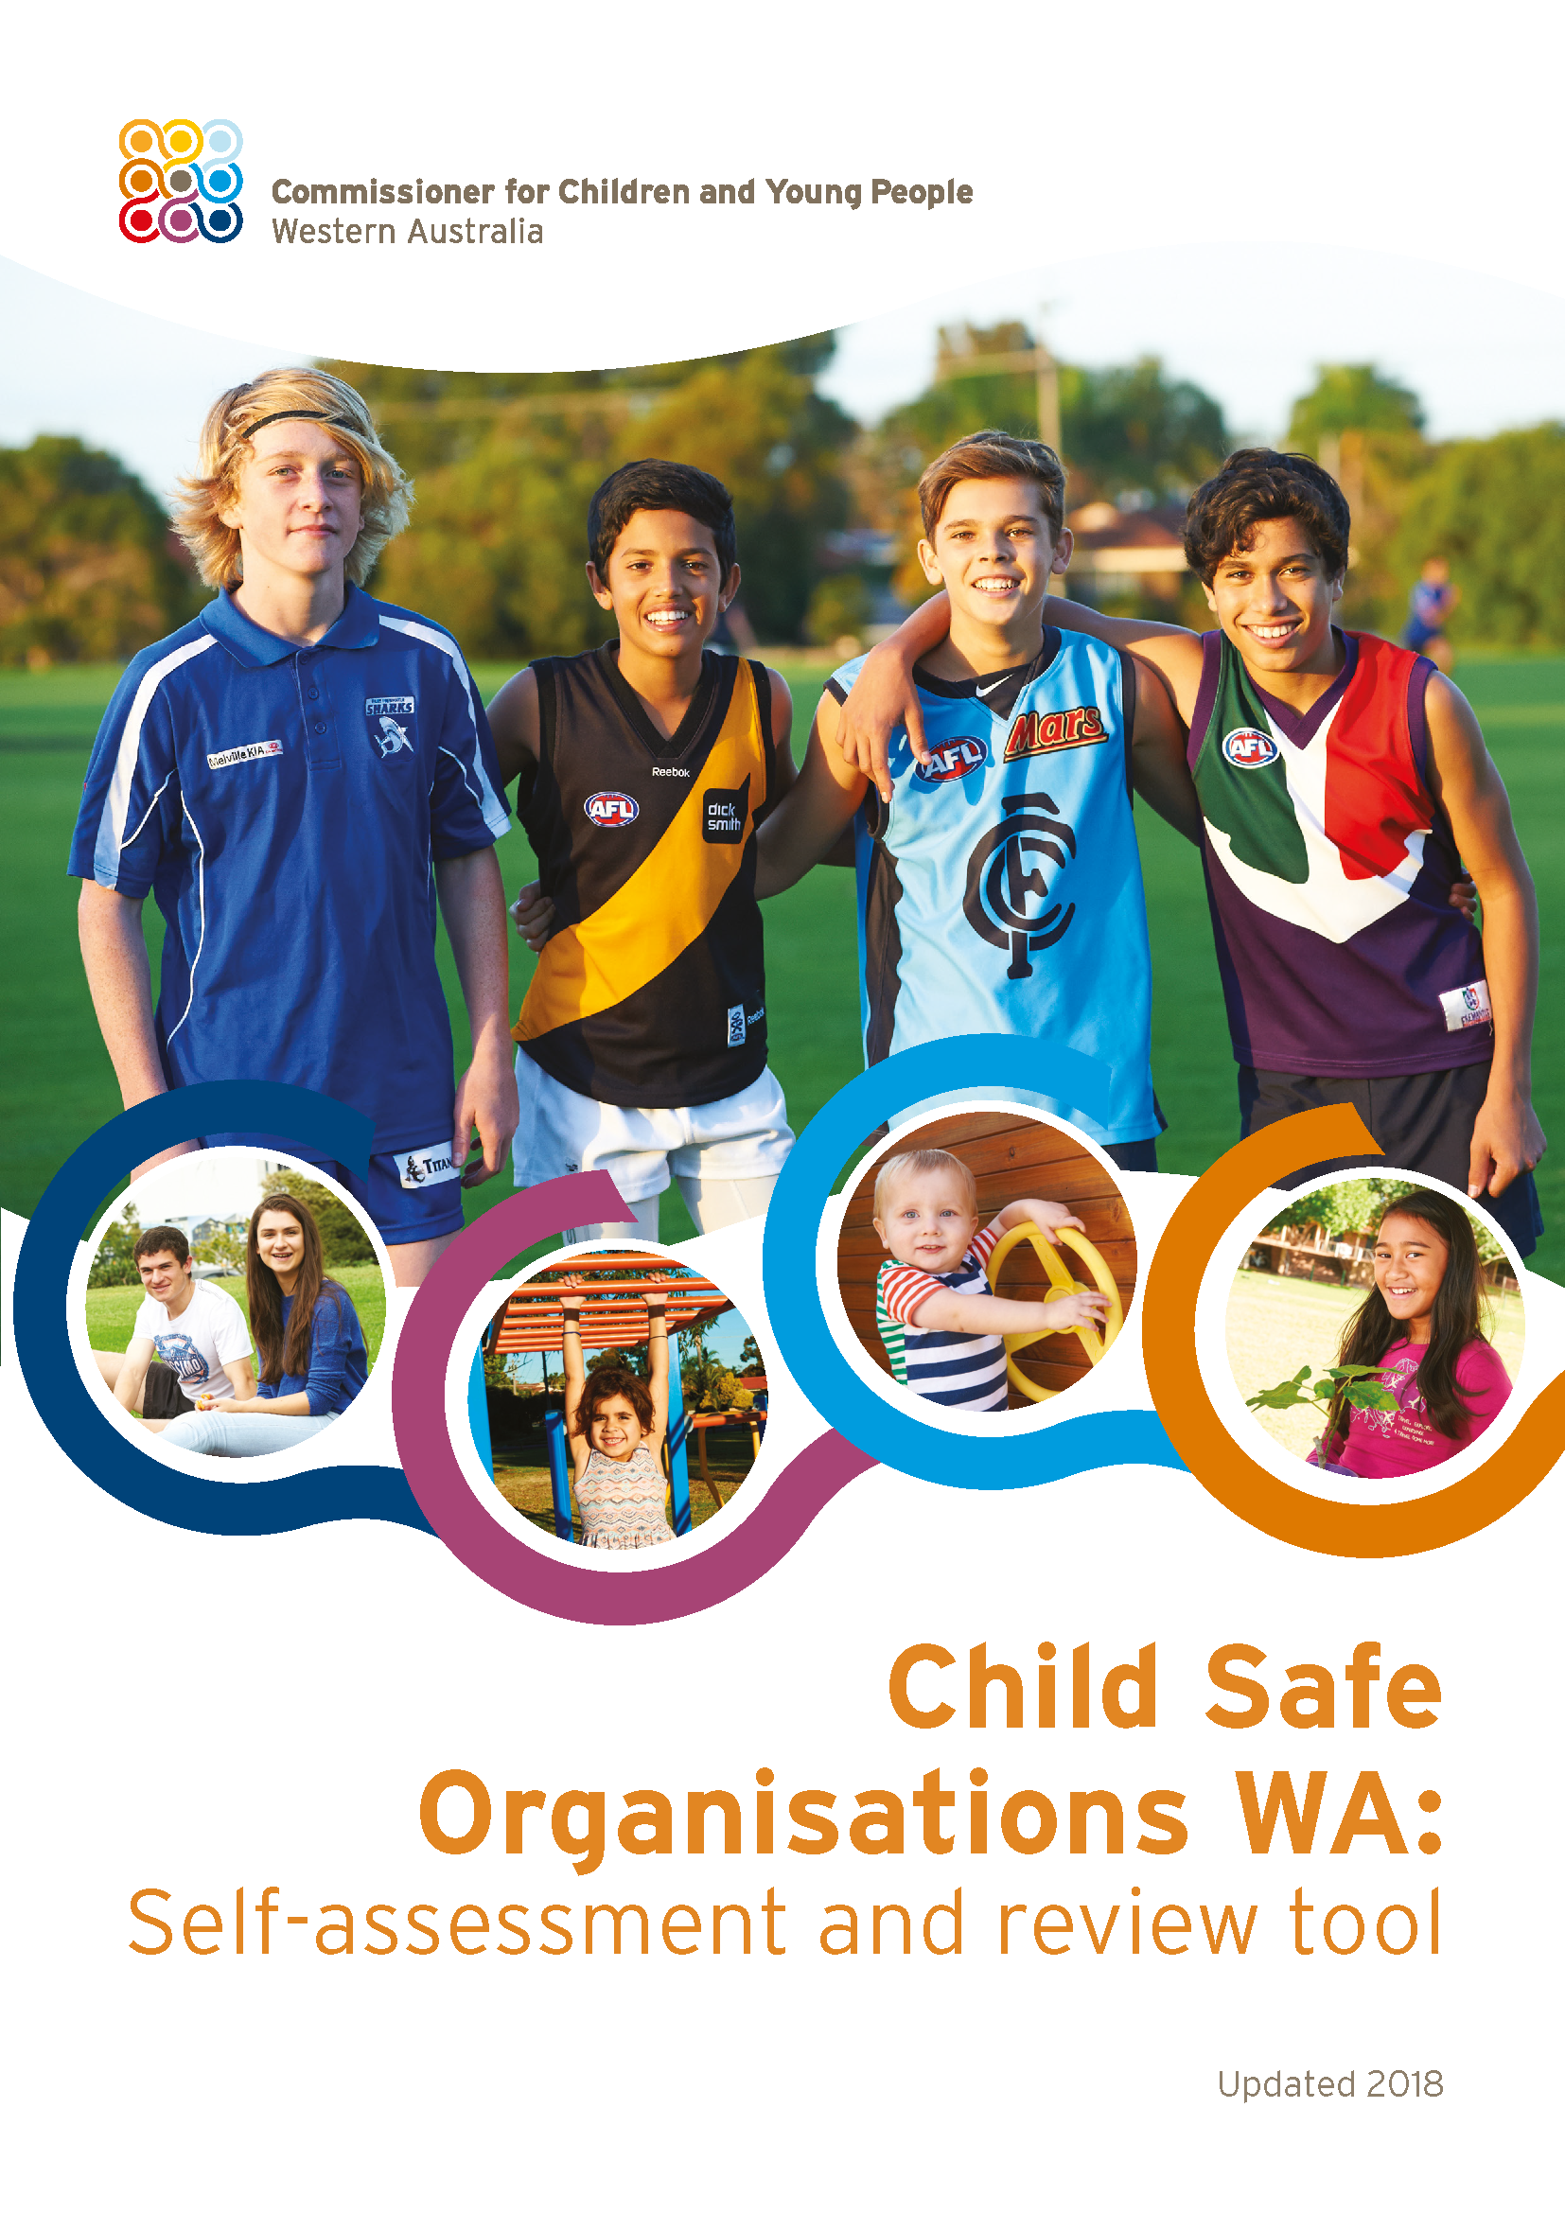
Disclaimer
This tool is intended to assist a broad range of organisations in their efforts to become more child safe. Each organisation will need to consider the information in the tool and develop strategies and practices suited to its own specific needs, consistent with its duty of care.
This tool is now provided in MS Word format which organisations can adapt to suit their implementation and review purposes.
It is expected that organisations will uphold the integrity of content within the document by not substantially reducing attention to each of the domain areas required to provide comprehensive child safe strategies.
Recognising Aboriginal and Torres Strait Islander People
The Commissioner for Children and Young People WA acknowledges the unique culture and heritage of our Aboriginal peoples and the contributions Aboriginal peoples have made and continue to make to Western Australian society. For the purposes of this publication, the term ‘Aboriginal’ is intended to encompass the diverse cultures and identities of the First Peoples of Western Australia and also recognises those of Torres Strait Islander descent who call Western Australia home.
.
Suggested citation
Commissioner for Children and Young People WA (2018). Child Safe Organisations WA: Self-assessment and review tool, revised. Commissioner for Children and Young People WA, Perth.

Alternative formats
On request, large print or alternative formats can be obtained from:
Commissioner for Children and Young People WA
Ground Floor, 1 Alvan Street, Subiaco WA 6008
Telephone: (08) 6213 2297
Facsimile: (08) 6213 2220
Freecall: 1800 072 444
Email: info@ccyp.wa.gov.au
Web: ccyp.wa.gov.au

ISBN: 978-0-9925924-8-6
Table of contents

Introduction 4
How to use the self-assessment and review tool 5
Domain 6
Leadership, governance and culture 6
Empowering children to participate 9
Involving family and community 14
Child safe and friendly policies 17
Managing staff and volunteers 20
Safe environments – physical and online 23
Child friendly complaints process and reporting 26
Education and development 30
Continuous improvement 33

Introduction
The Commissioner for Children and Young People WA released the Child Safe Organisations Guidelines & Self-Assessment Review Tool in April 2016.
Leaders of organisations, including board members, chief executives, directors and managers, are responsible for creating and maintaining an organisational culture where the safety of children and young people is a priority.
An ongoing cycle of assessment, action and review will assist leaders to reflect on their effectiveness in implementing child safe practices and to strive for excellence.
This self-assessment and review tool is designed to be used by organisations to:
- assess current organisational practices
- reflect on what the organisation is doing well
- identify areas requiring development
- review progress over time
- highlight positive changes
- acknowledge challenges or barriers
- outline what still needs to be done.
The Royal Commission into Institutional Responses to Child Sexual Abuse confirmed their Child Safe Standards and recommendations for the implementation of these nationally in their Final Report in December 2017. In June 2018 the Government of Western Australia accepted in principle the Royal Commission’s recommendations that the Child Safe Standards become mandatory for organisations that engage in child-related work and that they are independently monitored by oversight bodies who provide advice, information and support on the standards to organisations.
The Human Rights Commission is now progressing work on a National Statement of Principles for Child Safe Organisations with a view to these being signed off by the Council of Australian Governments.
The Commissioner for Children and Young People’s Child Safe Organisations WA Guidelines, the Royal Commission’s Child Safe Standards and the Human Rights Commission’s National Principles each outline equivalent elements and strategies that leaders and staff of organisations must understand and implement to provide comprehensive and tailored approaches to help children and young people to feel safe and be safe.
This tool has been updated to more clearly identify how organisations must pay attention to all children and young people they service by upholding equity and meeting diverse needs.: A child safe organisation will tailor their services and procedures to ensure; children with disability; children from diverse religious and cultural communities; Aboriginal children, very young children; children who have experienced trauma; lesbian, gay, bisexual, transgender and intersex children; and children living in remote locations have fair access to the relationships, skills, knowledge and resources they need to be safe, in equal measure with their peers.. Organisations should actively anticipate children’s diverse circumstances and backgrounds and respond effectively to address any specific needs and/or vulnerabilities.

This tool intended to be used with the publication Child Safe Organisations WA: Guidelines, available at ccyp.gov.au which provides additional information and examples of child safe practices.

How to use the self-assessment and review tool
This tool focuses on the culture and behaviours that are essential to establish and sustain a child safe and friendly organisation.
It is recommended the following steps are taken:
Consider and Determine
- who will complete the assessment/review (may be one person or multiple)
- who will be involved in providing information on the practices
- which leaders will consider the findings and approve the actions and timeframes
Assess and Document
Rate how the organisation performs on a series of ‘practices’ using the following five-point scale:
- Just beginning, self-assessment and planning
- Some progress, implementation of some aspects evident
- Most but not all aspects of the organisational practice are evident
- All aspects of the organisational practice are evident
- All aspects of the organisational practice are evident, and regularly reviewed
In rating each practice, consider the following:
- To what extent is the practice implemented and active?
- What can be seen? Use the examples provided as a guide.
- If asked, what would people say about the practice (children and young people, parents, carers, staff and volunteers)?
- What is evidenced in documents?
Identify and Action
- make notes that support the ratings
- articulate next steps for improvement
- identify who will do the work
- set timeframes for achievement
- have the assessment/review ratings, actions and timeframes approved by leaders
Monitor and Review
- use the review dates in the tool
- check on improvements identified in the previous assessment and the actions completed
- highlight positive changes
- learn from feedback, complaints, errors
- appraise all domains each time to ensure all aspects of child safe and friendly practices are evident

Domain  Leadership, governance and culture |  |  | Agency:  Work unit:  Completed by:  Date of review:  Date of next review:
Practices | Rating 1 to 5 | Evidence of  practice in action | Next steps | By whom | By when
An organisational commitment to being child safe and friendly articulates how the commitment is actioned and is publicly available.
Examples
- in public documents
- on the website
- on posters/flyers across locations
- included in induction/welcome packs
- on key internal documents/intranet
A clear accountability framework for child safe and friendly practices and procedures is promoted to staff, volunteers, families, children and young people and includes access to specialist advice about child safe practices internally and/or externally.
Examples
- everyone understand their own roles and responsibilities for child safety
- there are named people to discuss practices and concerns with
- policies and procedures refer to additional information, support and contacts
Leaders actively model and promote inclusive practices and a focus on child safety throughout the organisation. They provide opportunities for staff and volunteers to ask questions and to seek further advice on how to maintain a child safe environment.
Examples
- inclusion of child safety messages in newsletters, speeches
- regular agenda item in meetings and other communication
- monitoring the use of policies and processes in practice
Leaders support and enable staff and volunteers to undertake child safe and friendly practices.
Examples
- written into strategic/planning documents
- work is planned to minimise situations where children may be harmed
- the increased level or risk associated with some activities is accounted for
- time/funding is allocated to training/professional development
Upholding equity and meeting diverse needs.
Examples
- respect for diversity and cultural differences is embedded in all policies and practices and affirms a child and young person’s cultural identity or religious beliefs are fundamental to their wellbeing
- ensuring practices are in place that promote the inclusion and safety of children and young people with disability
- the increased level or risk associated with particular vulnerabilities of some children is accounted for

Domain  Empowering children to participate |  |  | Agency:  Work unit:  Completed by:  Date of review:  Date of next review:
Practices | Rating 1 to 5 | Evidence of  practice in action | Next steps | By whom | By when
Staff/volunteers promote children rights and responsibilities and promote personal safety and support.
Examples
- talking to children and young people
- about their right to feel safe
- steps the organisation takes to help keep them safe
- the rules of the organisation
- who to talk to/how to speak up if something is worrying them
- what to do if someone they know is being hurt
- protective behaviours education
- inclusion and valuing diversity is actively promoted
- child-friendly versions of rules/codes of conduct and complaint processes
- pro-active checking in with children
The organisation’s environment reflects the lives and identities of the children that engage with the organisation.
Examples
- artwork; positive images, photos and role models; maps of Aboriginal cultural boundaries, and/or different countries
- information, places or programs in other languages
Staff/volunteers run their activities in an inclusive way that adds to the self-esteem of all participants.
Examples
- when a child joins the organisation, assess their needs (including cultural and other diversity)
- facilitate connections between children through buddy systems
- work with other professionals and/or families to ensure activities are adapted appropriately
- apply knowledge from training; share good practices and previous learnings
- individual support plans are in place
- discuss/seek feedback on strategies with child, young person, parents, carers and/or service providers
Staff/volunteers provide opportunities for children to contribute to program and policy development and review.
Examples
- ask their opinions through discussions, activities and surveys on: how things could be better, what they like/don’t like, what makes them feel safe/unsafe in the organisation
- children design/write child-friendly versions of policies and procedures
Upholding equity and meeting diverse needs.
Examples
- strategies for promoting the participation of vulnerable children and young people are implemented
- staff and volunteers pay particular attention and response to the needs of children and young people with disability, Aboriginal children and young people, and children and young people from culturally and/or linguistically diverse backgrounds
- resources and activities reflect diversity across all categories

Domain  Involving family and community |  |  | Agency:  Work unit:  Completed by:  Date of review:  Date of next review:
Practices | Rating 1 to 5 | Evidence of  practice in action | Next steps | By whom | By when
There are opportunities for parents, carers and community members to participate in activities in the organisation.
Examples
- P&C committee, volunteers, Elders, cultural advisors
- open door policy for parents/carers to visit the organisation
- involvement in activities
- ‘drop in’ sessions
- morning teas
Barriers that may prevent parent, carer and/or community participation have been identified and addressed.
Examples
- discuss with parents how they would like to be involved in the organisation
- establish connections to external agencies or community leaders who can support the organisation to build culturally respectful practice
Opportunities for parents, carers and other community members to be involved in program and policy development and reviews within the organisation are actively promoted.
Examples
- actively invite feedback or opinions through informal discussions, forums, meetings, surveys
- supporting several parents/carers to speak with others and report back to the organisation on: how things could be better, how could the organisation work in more culturally appropriate ways, what they like/don’t like
Upholding equity and meeting diverse needs.
Examples
- provide timely information in a form and language that is accessible, including information about the organisation’s child safe and friendly policies and complaints processes
- seek guidance from experienced others in regards to the needs of children and young people with disabilities or complex needs or from culturally diverse backgrounds
- actively promote and support the diversity of family structures and relationships

Domain  Child safe and friendly policies |  |  | Agency:  Work unit:  Completed by:  Date of review:  Date of next review:
Practices | Rating 1 to 5 | Evidence of  practice in action | Next steps | By whom | By when
There is a coherent framework of policies and procedures which address safety and other relevant issues facing children.
Example – the framework details:
- the organisation’s commitment to child safety and the proactive steps taken to address child safety
- incorporates or makes reference to a code of conduct, a risk management strategy, feedback and complaints procedures, including responding to disclosures
- staff and volunteer management (including recruitment, education and development), ongoing supervision and disciplinary procedures
Child safe policies and procedures are applied to the day-to-day practice of the organisation’s child-related workers.
Example
- staff are trained in the policies and they are discussed in supervision, meetings, reviews
The policies and procedures are clear, easy to understand and accessible to all stakeholders, including staff, volunteers, families, children and young people. This may mean there are separate versions for each stakeholder group.
Everyone in the organisation, including staff, volunteers, children and young people and families can describe what the organisation has in place to keep children and young people safe or what to do in particular circumstances, such as how to make a complaint.
Examples
- everyone can describe:
  - what is in place to keep children safe
  - what to do in various situations and/or
  - what will happen if they raise a concern
- this information may be captured through surveys, informal discussions, focused meetings, the following of procedures
Upholding equity and meeting diverse needs.
Examples
- policies and procedures make clear reference to additional considerations related to Aboriginal cultures, disability, culturally and linguistically diverse backgrounds, and other experiences and needs
- specific strategies tailored to the needs of Aboriginal children, children with disability, and children from culturally and linguistically diverse backgrounds, to ensure their safety and participation in the organisation is implemented and outcomes monitored

Domain  Managing staff and volunteers |  |  | Agency:  Work unit:  Completed by:  Date of review:  Date of next review:
Practices | Rating 1 to 5 | Evidence of  practice in action | Next steps | By whom | By when
All workers, including paid staff and volunteers, are carefully selected using a recruitment strategy that includes multiple checks.
Examples
- multi-person interview panel
- transparent short-listing process
- standardised reference checks
- identity checks
- qualification verification
- Working With Children Check
- National Police Check
Staff and volunteers participate in a structured induction process which includes training, advice and ongoing support in relation to child-safe policies and day-to-day child-safe practices in the workplace.
Regular supervision and support is provided to staff, which includes the opportunity to discuss child-safe practices and checks for understanding of policies and procedures.
Examples
- regular training, professional development and/or information sessions
- relevant aspects incorporated within performance plans
- circulation of information about policies and procedures
- active communication of internal and/or external supports
- staff mentoring
Staff and volunteer management is supported by clear disciplinary and grievance procedures, which are linked to codes of conduct and feedback/complaint mechanisms.
Upholding equity and meeting diverse needs.
Examples
- Staff and volunteers are from a diversity of cultures, abilities and identities
- Orientation, induction and ongoing support and supervision has specific content related to respect for and meeting the needs of children, regardless of their individual characteristics, cultural backgrounds, and abilities

Domain  Safe environments – physical and online |  |  | Agency:  Work unit:  Completed by:  Date of review:  Date of next review:
Practices | Rating 1 to 5 | Evidence of  practice in action | Next steps | By whom | By when
A practical risk management strategy has been developed, which is adapted for the different settings in which the organisation works and the particular needs of the children and young people.
Examples
- visibility has been considered and activities planned accordingly
- where visibility is not possible, other practices are strengthened
- access to the organisation is actively monitored
- off-site activities are planned to take into account the physical environment
- procedures and guidelines for managing toilet breaks, changing clothes and personal care are in place
- guidelines about online environments
Behaviours that are inappropriate with children and young people and workplace factors that can affect the likelihood of such behaviour occurring have been identified. Strategies to minimise these activities occurring have been included in the practical risk management strategy.
Examples
- guidelines about taking and storage of photos of children
- guidelines for staff and volunteers about communication with children via personal phones, emails and social media
Behaviours that are inappropriate with children in an online environment have been identified. Strategies to minimise these behaviours and activities occurring have been addressed.
Examples
- guidelines and education about cyber-safety and online security for children and young people provided, or links to education resources provided
Upholding equity and meeting diverse needs.
Examples
- particular attention is given to safety and diverse needs of children in closed or segregated environments, such as out-of-home care, boarding schools, youth detention, specialist education facilities and disability support settings
- a strong prevention and awareness focus, by providing information and education accessible to all children and parents about physical and online safety strategies

Domain  Child friendly complaints process and reporting |  |  | Agency:  Work unit:  Completed by:  Date of review:  Date of next review:
Practices | Rating 1 to 5 | Evidence of  practice in action | Next steps | By whom | By when
There are clear procedures for staff, volunteers, families, children and young people to provide feedback, raise concerns or make formal complaints. These procedures are actively promoted.
Examples
- staff and volunteers discuss and invite complaints/feedback
- easily accessible and visible posters/flyers/flowcharts
- information on the website
All concerns from children, staff, volunteers, family and community members are taken seriously and acted upon.
Examples
- there is a clear process for raising complaints and concerns, including a record keeping system that is linked to decision making and disciplinary processes about concerns
- processes include approaches to dealing with situations in which a child may cause harm to another child
- there are several pathways to escalate concerns
- complainants are kept informed of the progress and outcome
- feedback and complaints lead to improvement in service planning and/or delivery
Barriers that may prevent staff, volunteers, families, children and young people from providing feedback, raising concerns or making a formal complaint have been identified and addressed.
Examples
- cultural appropriateness of the processes have been considered
- there are ways for people with communication difficulties to raise concerns
- there is an anonymous option
- complaints from an advocate or someone speaking on behalf of children are accepted
- staff/volunteers have multiple colleagues to discuss concerns with; not restricted to line managers
There are multiple pathways for staff, volunteers, children, young people and parents/carers to provide feedback, raise concerns or complaints.
Examples
- incorporated into activities
- anonymous dropbox or online system
- regular invitations to talk or ‘checking in’ with people
- designated staff role for promoting child safety (more than one)
Upholding equity and meeting diverse needs.
Examples
- provides information in accessible, age-appropriate and meaningful formats to children and families mindful of their diverse characteristics, cultural backgrounds and abilities
- uses translation services and bicultural workers with knowledge of child abuse issues, particularly to facilitate disclosure, reporting and complaint handling

Domain  Education and development |  |  | Agency:  Work unit:  Completed by:  Date of review:  Date of next review:
Practices | Rating 1 to 5 | Evidence of  practice in action | Next steps | By whom | By when
Training and resources provided to staff/volunteers are accessible, evidence-informed and reviewed regularly. Where necessary/applicable, external experts support or provide training.
Examples
- resources, or information about resources, are prominently displayed in staff areas or on intranet
- resources are from organisations that have expertise in the safety of children and young people
Training addresses the needs of the whole organisation, including leaders and governing bodies, to ensure they have the knowledge and information needed to understand their responsibilities.
Examples
- the dynamics of child abuse
- how to identify and respond to behaviour by others that is considered risky or harmful to children
- being culturally responsive
- supporting the participation of children and young people, families and communities
- the process of disclosure and responding to children and young people
- policies, procedures and reporting within the organisation, and legal reporting obligations
- where to access further support internally and/or externally, including what do to if concerns are not acted on appropriately
Ongoing professional development/training is provided to support ongoing responsiveness to, and application of, child safe and friendly practices in the workplace.
Upholding equity and meeting diverse needs.
Examples
- Training is culturally responsive to the needs of Aboriginal, migrant, refugee and multi-faith communities and to the needs of people with disability; for example, by being delivered jointly by bilingual and/or bicultural workers
- Information on education opportunities for children, young people and parents and carers about child abuse, protective behaviours and online safety is provided in accessible formats
- Training includes barriers that prevent children from disclosing abuse or adults from recognising children’s disclosures, with particular attention to children’s cultural contexts, languages, cognitive capabilities and communication needs

Domain  Continuous improvement |  |  | Agency:  Work unit:  Completed by:  Date of review:  Date of next review:
Practices | Rating 1 to 5 | Evidence of  practice in action | Next steps | By whom | By when
Regular reviews of policies and procedures, and the enactment of policies and procedures, are undertaken and are informed by a range of information/data sources from the organisation.
Examples
- planned activities, brainstorming sessions, meetings, forums, etc.
- regular proactive discussion/input about practice as part of general meetings; informed by general feedback, input from staff, volunteers, children, young people, carers and parents
Policies and procedures are dated and new versions/changes are brought to the attention of staff, volunteers, parents, carers, children and young people and supported by relevant information and/or training as required.
The organisation fosters open and positive relationships with other organisations to share lessons learned, experiences and practices.
Examples
- working groups
- network meetings
Self-assessment and review of all child safe organisation domains and strategies are undertaken regularly and leaders in the organisation are aware of the outcomes, any areas requiring attention and the completion of necessary tasks.
Upholding equity and meeting diverse needs.
Examples
- remains attentive and responsive to new challenges, such changes of children in the organisation or to the diversity of needs of children and families
- if serving children who are at risk, more vulnerable or hard to reach, gives attention to the evolving evidence base in relation to the safety of all children, being mindful of their individual characteristics, cultural backgrounds and abilities
- ensures all children and families, including those from diverse backgrounds are supported to give feedback and input into review processes

Completed by ___________________________ Date: ___________
Approved / Noted by _____________________ Date: ___________
Approved / Noted by _____________________ Date: ___________
Approved / Noted by _____________________ Date: ___________

